**Project 2: Stock Market Prediction using Machine Learning (Regression)**

Problem Statement : Predict the stock price of Amazon for 30 days in future using Machine Learning.

Solution :

Import all libraries:

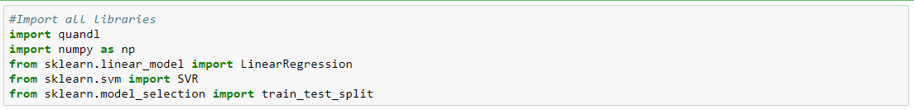

Get the stock data:

Here we will get stock data from Quandl from 1997 to Februrary 2018 as the data after 2018 is not available on Quandl.



Get the Adjusted Close Price:



Creating a variable for predicting 'n' days out into the future:

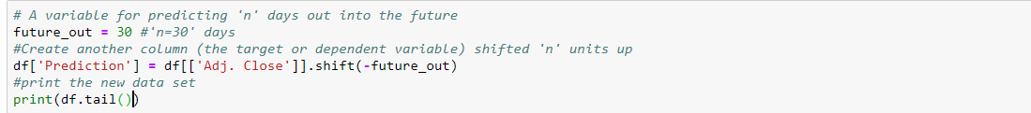

Create the independent data set X and converting into an array:

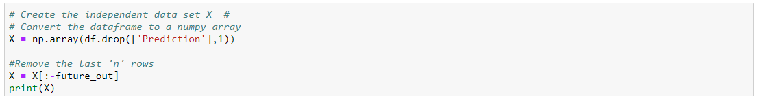

Create the independent data set y and converting into an array:

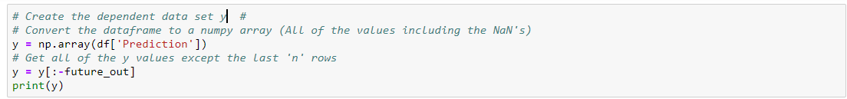

Split the data into 80% training and 20% testing:



Create and train the Support Vector Machine (Regressor):



Testing Model: Score returns the coefficient of determination R^2 of the prediction:



Create and train the Linear Regression Model:



Testing Model: Score returns the coefficient of determination R^2 of the prediction:



Set x_forecast equal to the last 30 rows of the original data set from Adj. Close column:



Print linear regression model svm model predictions for the next 'n' days:

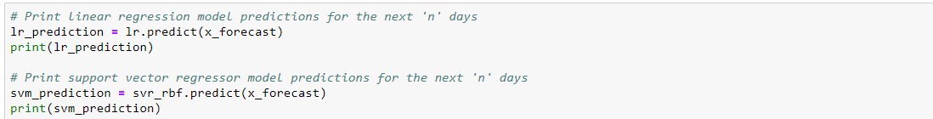

Now we will import AMZN data from 13th Feb-2018 to 27th Mar-2019 TO compare our predicted values:



Now we will plot a comparison graph:

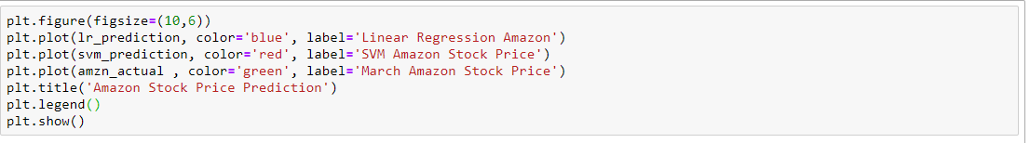

Output:

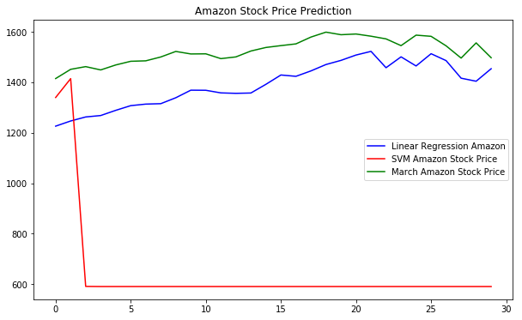

Findings:

Here we can notice that even though linear regression and svm had almost the same confidence score , linear regression proved to be the better model between the two. Further on we will now try LSTM model.